**Skin Care Products**

**Toogie’s Lip Balm**

***Soothes and protects your lips***

**Ingredients:**

**Beeswax, sweet almond oil, castor oil, bee propolis, vitamin e and peppermint.**

**Toogie’s**

**All Purpose Skin Cream**

***Made with love and everything from the hive***

**Ingredients:**

**Olive oil, castor oil. beeswax, honey, pollen, royal jelly, bee propolis, vitamin c oil, vitamin d.**

**The scented cream has lavender.**

**Toogie’s Face Cream**

***Made with 3 times more Royal Jelly than the All Purpose Skin Cream***

**Ingredients:**

**Olive oil, beeswax, royal jelly, castor oil, honey, pollen, bee propolis, pollen, vitamin c oil, vitamin e oil.**

**Raw Honey**

***Not processed or***

***Pasteurized***

**Honey straight**

**From the hive,**

**Extracted**

**From the comb,**

**Strained, and**

**Poured into jars.**

**Sold in pints or quarts.**

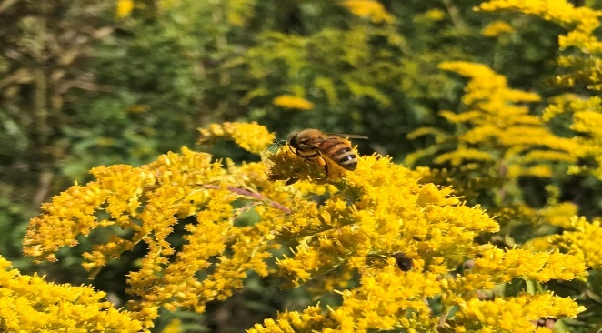

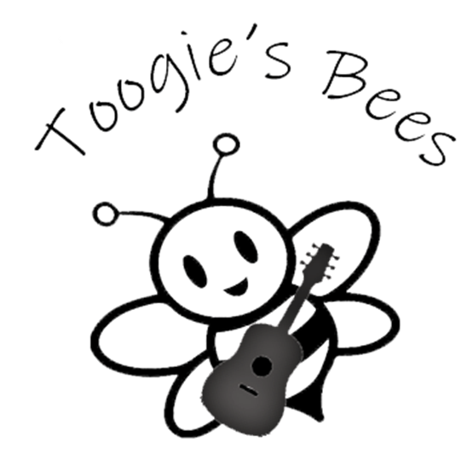

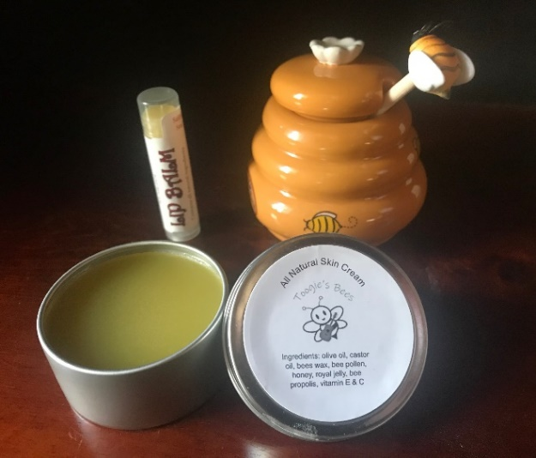

Toogie’s Bees

3343 W 900 N

Alexandria, IN 46—1

317-730-2085

[toogiesbees@gmail.com](mailto:toogiesbees@gmail.com)



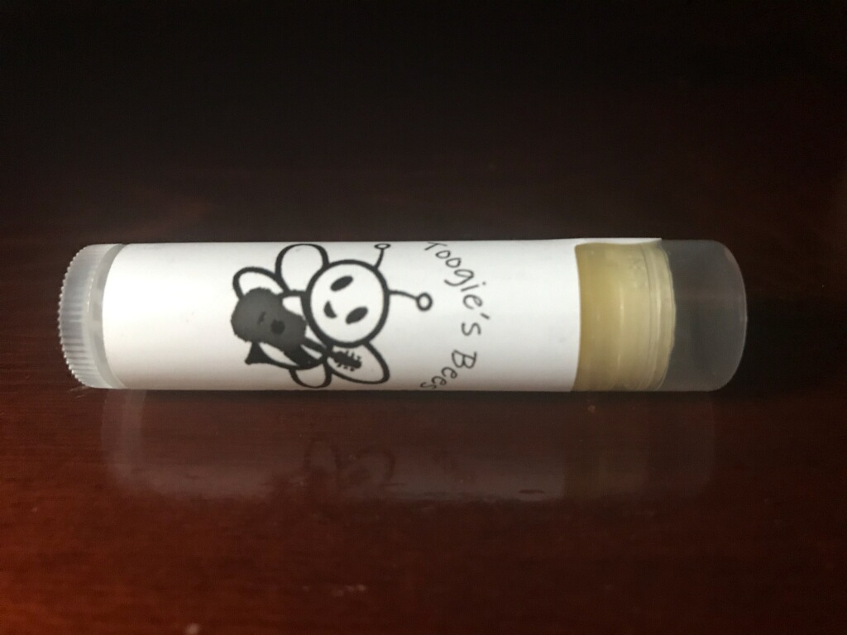

**Toogie’s**

**Lip Balm**

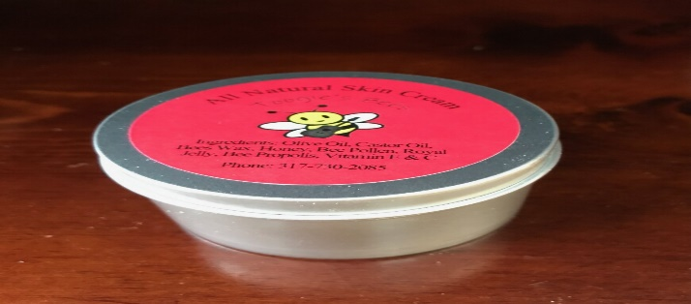

**Toogie’s All Purpose Skin Cream**

***Scented and Unscented***

**Skin Care Products**

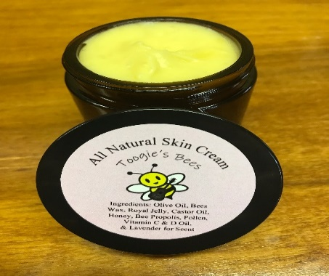

**Toogie’s Face Cream**

***Three Times More Royal Jelly***

**Toogie’s**

**Lip Balm**





**Other Products**

**Raw Unfiltered Honey**

Quarts and Pints

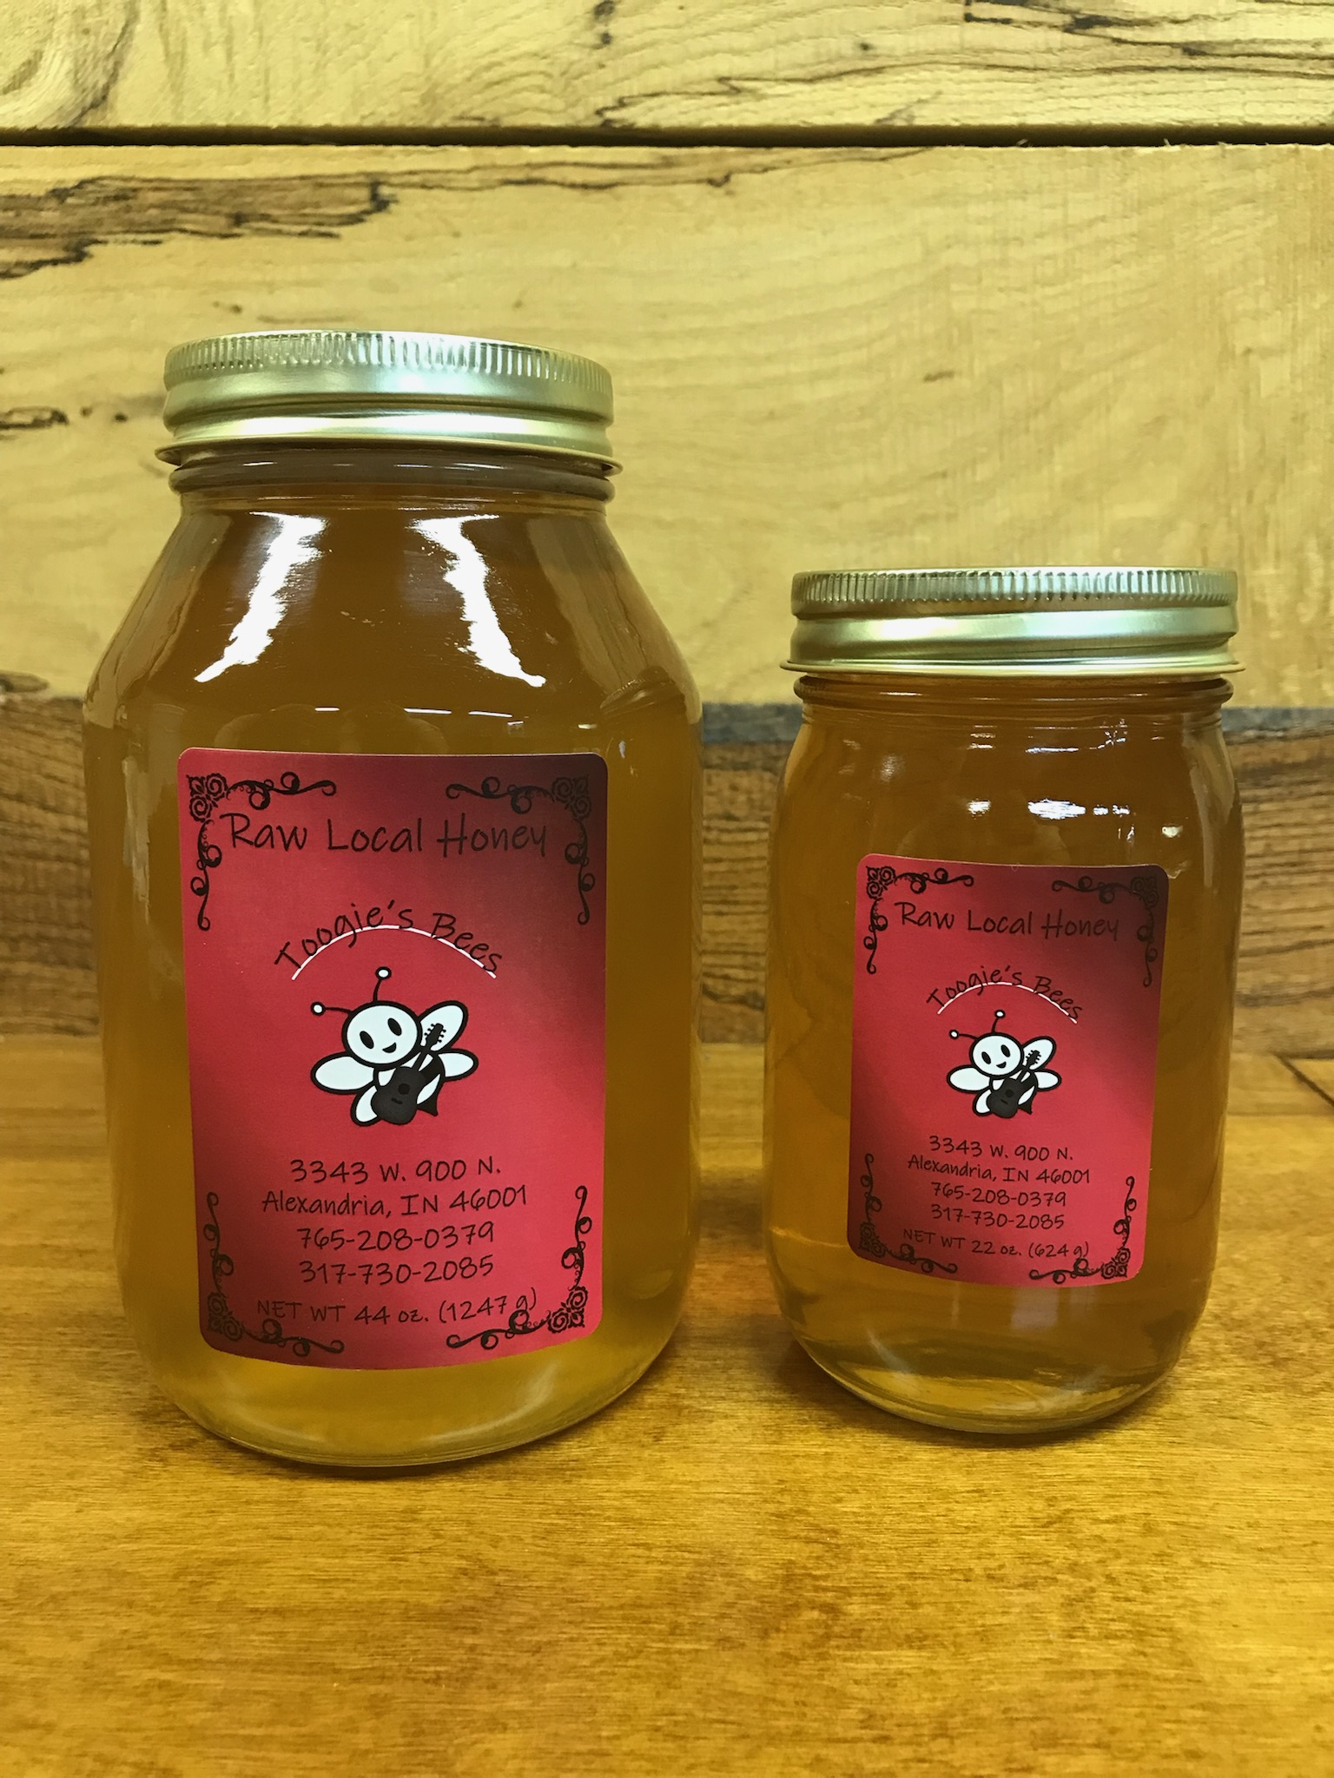

**Gift Boxes**

***Seasonal and upon Request* 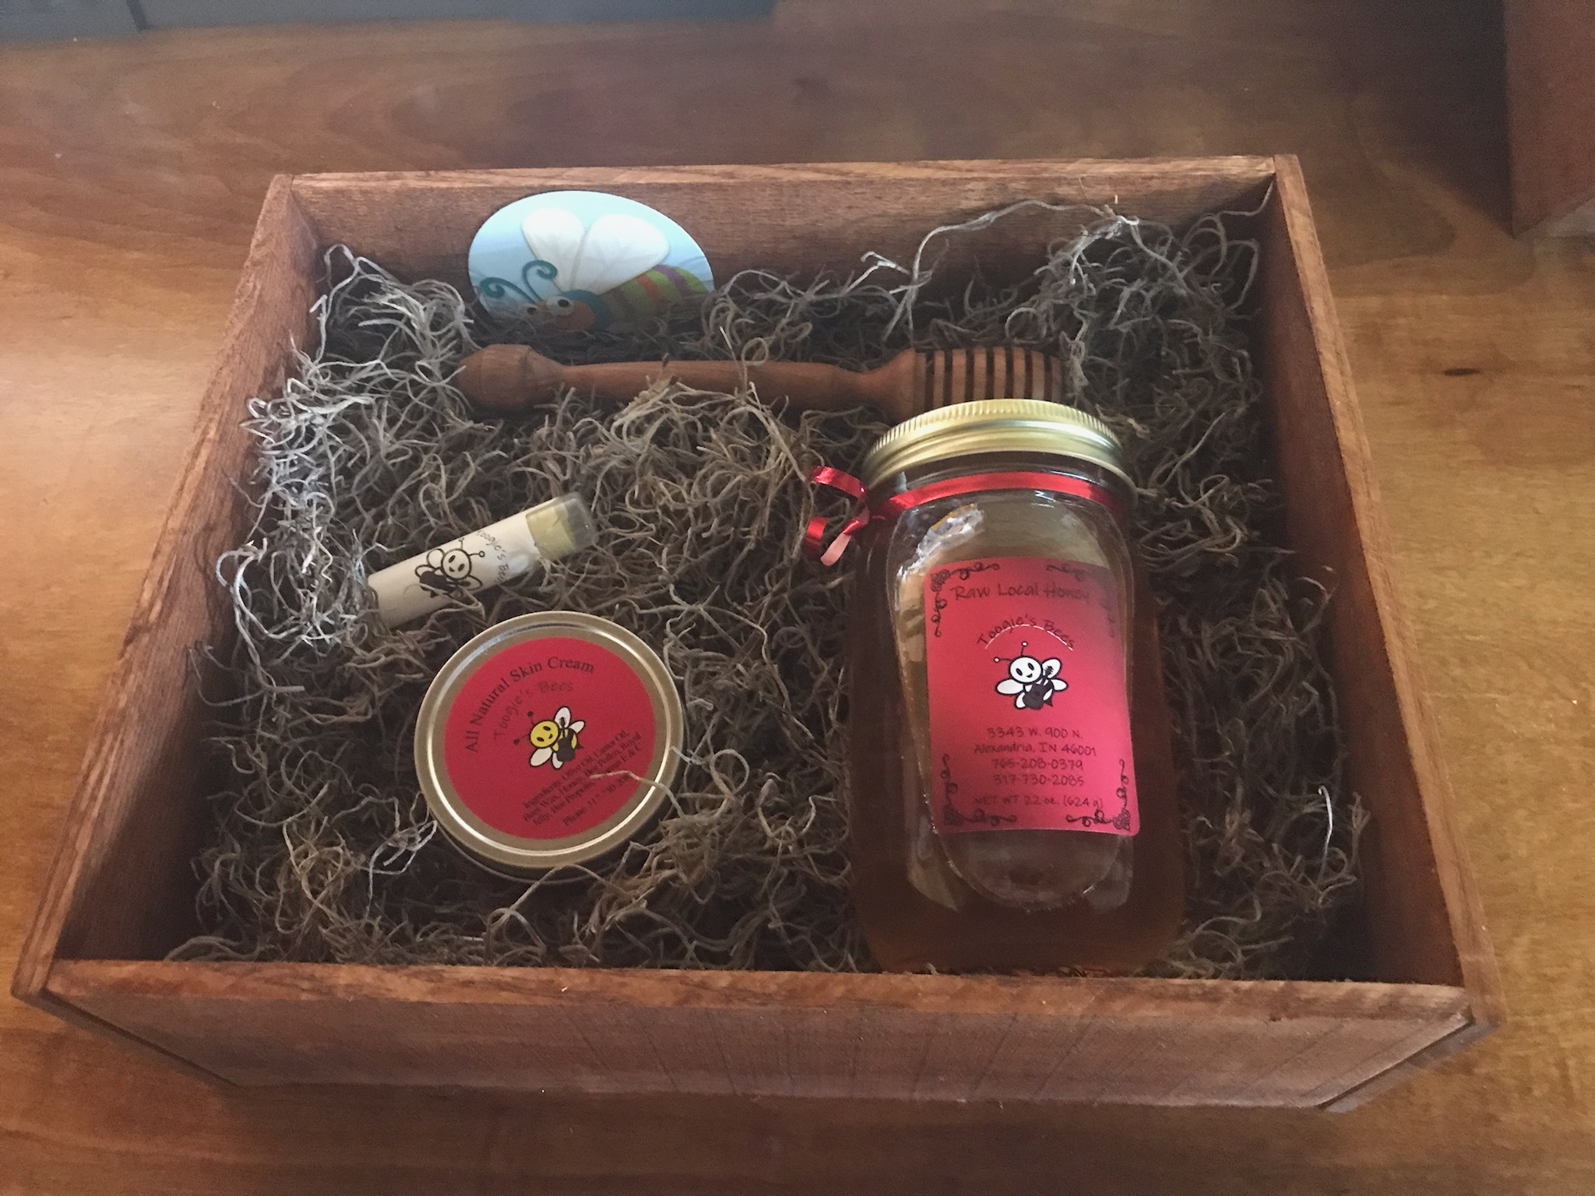**

**Propolis**

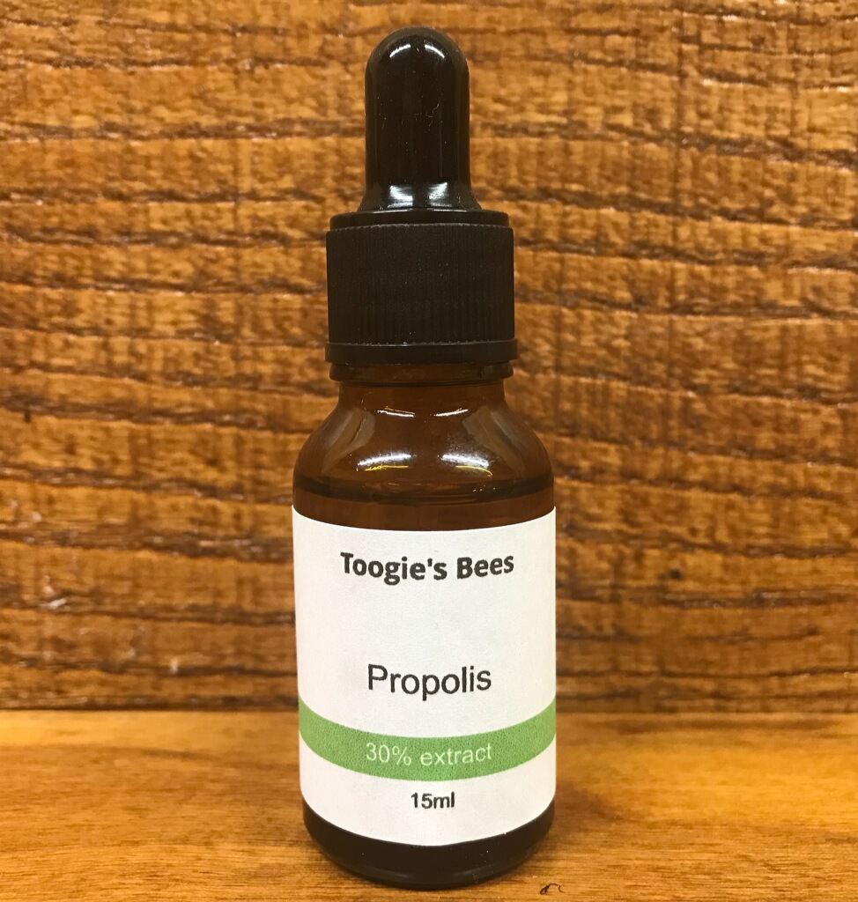

Pricing and Ordering

Please call 317-730-2085,

Message Toogie’s Bees

On Facebook or Email

toogiesbees@gmail.com

